(Approx. 944 words)

New and Handy Tools in Word 2013
By Nancy DeMarte, 1st Vice President, Sarasota Technology User Group, FL
January 2015 issue, Sarasota Technology Monitor
www.thestug.org
ndemarte (at) verizon.net

Each time Microsoft issues a new version of its Office suite, bugs are fixed and upgrades done. Office 2013 (called Office 365 for those with a subscription) is no exception. These tools have either appeared for the first time in the 2013 version or have been repositioned on the command Ribbon, which was introduced in Office 2007. For those unfamiliar with the ribbon, here is a review of how it is set up:

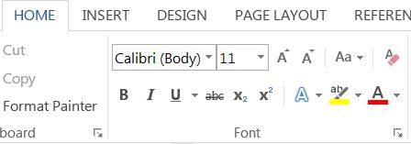
Tabs appear along the top of the ribbon: Home, Insert, Design, etc. When you click a tab name, a new set of tool icons appears across the screen.

Groups appear along the bottom: Font, Paragraph, etc. Each group on a tab is a cluster of related tool buttons. The Font group is pictured here.

Here are a few of the new tools in Word 2013 that I have found especially useful, organized by their location on the ribbon:

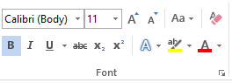
Clear all Formatting (Home tab – Font Group) Located in the top right corner of the Font group, this tool is a quick way to take your formatted text back to its basic state. “Formatting” text means adding color or effects. To remove all formatting, select the text you want and click the button. If the selected text is already unformatted, the icon will be grayed out and therefore unusable.

Text Effects (Home tab – Font Group)
The glowing A in the bottom row of the Font group lets you add special formatting to selected text, including outline, shadow, reflection, and glow. Select the text you want to apply an effect to, then click the right arrow next to an effect category to refine the effect or make your choice from the sample characters in the gallery. To remove the effect, click the Undo button or the Clear all Formatting icon.

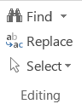
Select (Home tab – Editing Group)
The easily overlooked Select command is a speedy way to 1 - select an entire document with two clicks (Select, then Select All), 2 - select only the objects, such as shapes, photos, and text boxes (Select - Select Objects), or 3 - select all text with similar formatting, such as all colored or highlighted text, using a selection pane. This tool saves a user from awkward actions like having to drag the mouse over a multipage document to select it.

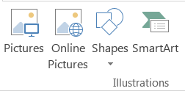
Online Pictures (Insert tab – Illustrations Group)
Gone are the days when just a few pieces of clip art were installed with Word for use in documents. The new Online Pictures tool opens to Internet places where you can get graphics of all kinds. You can search the huge collection of free royalty clip art and photos at Office.com, use the Bing search engine to look through the web for graphics, browse your personal collection on OneDrive, or insert a picture from Facebook or Flickr. The Pictures command, next to Online Pictures, gives you access to photos in your Pictures folder or other folders on your computer.

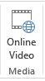
Online video (Insert tab – Media Group)
Clicking this icon will set you up for a Bing search of web videos or the well-known YouTube video collection. You can insert the video link directly into a document and, if you are connected to the Internet, play the video without leaving Word. This is new to Office 2013.

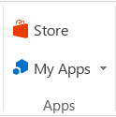
Apps group (Insert tab – Apps group)
This whole group is exclusive to Office 2013/365 because this is the first version of Office to offer access to the Office store. From within any document, you can download apps from the Office Store and store them in My Apps. New apps are being added to the store all the time; most are free.

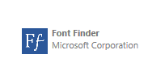
Recently I downloaded a new free app called Font Finder, which I can use to organize my fonts by category; e.g., Classic, Handwriting, Fancy, Retro, and others. This certainly beats scrolling through the large alphabetical list of fonts. To use it, I select some text, click My Apps – Font Finder – Insert, which opens the app to the right of my document. After reading the instructions, I click Continue, which displays the font categories or lets me search all fonts. I click a category like Fancy, and click a font name to apply it to my selected text. If I like this font, I can click the star next to it to put it in my Favorites list. If not, clicking Undo will return it to its original font.

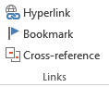
Bookmark (Insert tab – Links group)
This tool has been around through a few previous versions of Word. A useful tool for those who deal with long documents, the Bookmark command lets you put a bookmark in any spot of your document and link it to text in another part of the document. If you were writing a book or long article, for example, and had a page of charts in the appendix, you could bookmark each one and set up a hyperlinked word or phrase anywhere in the document text which, when clicked, would take you directly to its chart.

NOTES about tools on the Office ribbon:
-- The definition of each of the tools on ribbons in Office programs can be viewed by moving your mouse arrow (without clicking) over the tool’s icon. Many tools also give specific details about how to use them if you click “Tell me more” below the definition.
-- These are only a few of the new and useful tools on the ribbon in Office programs. Others will be reviewed in future articles.

